LAB 1

1. 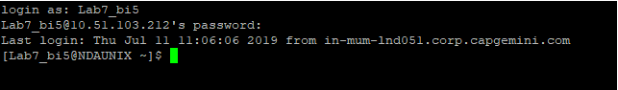
2. Exit command – Ctrl+D